

Mail Client

**COURSE BASED PROJECT**

**(2021 – 2022)**

**Computer networks**

**(B.Tech, 3nd year, 1nd Semester) OF**

**E.MADHUKAR (19071A3213)**

**G.JASHWANTH (19071A3220)**

**K.SUMANTH (19071A3228) S.SUPRAJA (19071A3250)**

**OMEGA (19071A3256)**

**Department of Computer Science and Engineering**

**VALLURIPALLI NAGESWARARAO VIGNANA JYOTHI INSTITUTE OF ENGINEERING &**

**TECHNOLOGY (AUTONOMOUS INSTITUTE)**

**NBA Accredited and NAAC Accredited WITH ‘A GRADE**

**VNR Vignana Jyothi Institute Of Engineering & Technology**

(Autonomous Institute)

**Department of Computer Science and Engineering**

**CERTIFICATE**

This is to certify that the Course based project entitled **“MAILING CLIENT”** submitted in partial fulfillment for the course computer networks offered during the 3nd year, 1nd semester B.Tech (CSBS), is a result of the bonafide work carried out by the students bearing the Roll. No’s 19071A3213, 19071A3220, 19071A3228, 19071A3250,19071A3256 during the year **2021-2022**.

This is the novel concept adopted by VNR VJIET, to relate classroom learning to the real-time applications. It enhances self-learning, internalizing the extended concepts and effective team management.

**INTERNAL GUIDE**

**G.S RAMESH**

**ACKNOWLEDGEMENT**

An endeavour over a long period can be successful only with the advice and support of our well-wishers. We take this opportunity to express our gratitude and appreciation to all of them.

We wish to express our profound gratitude to our **Principal and HOD, CSE** department**, VNR Vignana Jyothi Institute of Engineering and Technology** for their constant and dedicated support towards our career moulding and development.

Finally we wish to express a deep sense of gratitude and sincere thanks to our parents, friends and all our well-wishers who have technically and non-technically contributed for the successful completion of this course based project.

**E.MADHUKAR (19071A3213)**

**G.JASHWANTH (19071A3220)**

**K.SUMANTH (19071A3228)**

**S.SUPRAJA (19071A3250)**

**OMEGA (19071A3256)**

**­**

## INDEX

|  |  |  |
| --- | --- | --- |
| **S.NO** | **TOPIC** | **PAGE** |
| 1) | **ABSTRACT** | **1-1** |
| 2) | **ABOUT PROJECT** | **2-3** |
| 3) | **RUNNING THE PROJECT** | **4-5** |
| 4) | **CONCLUSION** | **6** |

ABSTRACT

Chat room is a space for people across the globe to communicate with each other about various topics. The topics can range from anything such as app development to any recipes made in the kitchen. Chat rooms are great platforms for learning how to communicate.

Several network systems are built to communicate with one another as well as made available through service-oriented architectures. In this project, the client server architecture is used to develop a chat application. Firstly a chat application is created for both Client and [Server](https://www.projecttopics.org/security-network-programming-secured-client-server-chat-application.html) which is based on Transmission Control Protocol (TCP) where TCP is connection oriented protocol and is a reliable connection protocol. As security is the key factor while communicating over a network.

We shall introduce to you how to make a small chat room using the basic concepts with sockets and python.

**ABOUT PROJECT**

This is a Mailing client. Here we can send an email and chat with each other using simple python code .

# INTRODUCTION

A software project comprising of a strongly built email client that allows users to send emails to any email address and at the same time allows receiving emails too. Today, emailing is the most basic need of communication for people and organizations. It is a secure system where user can access emails in a more efficient way. The project basically connects user's existing account with the system. Thus user can send and receive the messages into the system's database. The protocol used establishes a reliable connection for transferring and receiving emails.

**Features of the system:**

* The email client uses SMTP and POP3 services to send and receive emails.
* SMTP is a protocol used for sending email and POP3 used for retrieving emails.
* Our software system allows users to compose emails as per user requirements along with title destination email and the message body.
* The email client comprises of an inbox as well as spam folder for receiving emails.
* Emails consisting of content as per predefined rules (not overly populated with images and links) are saved in email inbox.
* Emails containing images or links above a certain limit are saved in the spam folder.
* Thus the emailing system provides a secure and advanced pop3/SMTP based client application.
* The system provides a robust understanding of an email client and allows for efficient sending and receiving of emails.

**Modules:**

* User registration: User has to first register into the system by providing their id and password of the account that he wants to integrate.
* User login: User can now login into the system by providing system's id and account password.
* Account Integration: The system then automatically synchronizes the system with the account, extracts all data from account and stores its database.
* Composing and sending emails: User can compose mails and by providing the recipients id the system directly sends the mail to it.
* Spam Functionality: The concept of putting mails into spam is according to the pre-defined keywords. If the mail consists of these keywords, the system puts them into spam folder.

CODE#

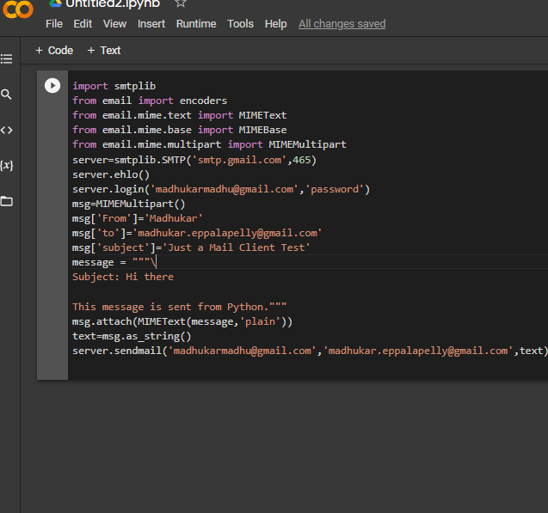

## Email Client Software Project Abstract:

[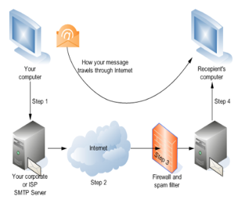](https://www.codewithc.com/wp-content/uploads/2014/10/email-client-system-architecture.png)System Architecture

The ISPs mail server handles the emails sent from an ISP (Internet Service Provider); the ISP [mail server](https://www.codewithc.com/mail-server-project-java/)is similar to an electronic post office. The sent email first comes to the mail server; it is then processed and forwarded to the collector’s destination where another mail server is situated.

The collector mail server receives all the incoming emails and sorts them electronically in the collectors’ mailboxes. Then, the collector or the recipient of the email has to use their email program to pick up the email. This is done by directly connecting to the mail server through the program, and then the received items can be seen in the mailbox.

The problem with the existing Email Client System is that mailing is done through browser by using services like Hotmail, Yahoo, Google, etc. These systems use HTTP port 80 to access the emails, and the overall procedure here is not safe to send confidential messages. This existing system can be easily hacked by hackers, some data may be modified or even lost.

With the proposed Email Client Software, email client program is run on Java coding. It can be used to send/receive emails very securely. Additionally, the cost of mail client in the proposed system is less compared to the mail services.



**Conclusion:**

This Email Client Software can be implemented to fulfill all the client requirements. The system interface is very user friendly, and the overall system has been successfully tested. It has a broad future scope as new features can be incorporated in the present proposed system. The system can be used for online [sharing of data](https://www.codewithc.com/file-transfer-chat-project-java/) without the involvement of authority by which users can read message from any part of the world.